Physics 30 Lesson 3C Conservation of Energy II

As we saw in Lesson 3B, energy may be transformed from one type to another, from kinetic to potential or kinetic to heat, but the total amount of energy is conserved.
Total Initial Energies = Total Final Energies

The problems in this lesson are a little more difficult, but the basic process of solution remains the same.

Simple Harmonic Motion – Conservation of Energy
In Physics 20 you learned how to calculate the period of motion for vibrating springs and swinging pendulums. In Physics 30 we find that vibrating springs and pendulums are examples of objects that obey the law of conservation of mechanical energy. (For these problems we ignore the effects of friction.)

A. The Pendulum
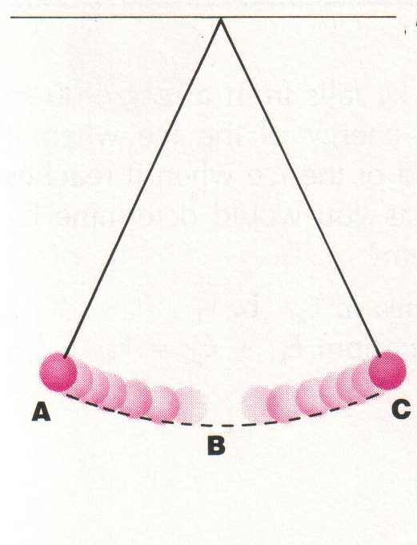
When a pendulum is pulled to the side (position A), the pendulum has potential energy. When the pendulum is released, the potential energy is transformed into kinetic energy until all of the potential energy is converted into kinetic energy at the bottom of the swing (position B). The pendulum keeps swinging through the equilibrium position, losing kinetic energy as it regains potential energy. Assuming that there is no loss to heat or friction, it will rise to a point equal to the original height above the equilibrium position(position C). At the top of the swing the pendulum is instantaneously at rest (E_{k} = 0) and all of the energy is in potential form. Then it will begin to swing back toward the equilibrium position.

The figure below is a graph of the changing potential and kinetic energies of a pendulum bob during a one-half period of oscillation. Note that the sum of the kinetic and potential energies is constant.
E_{p} + E_{k}
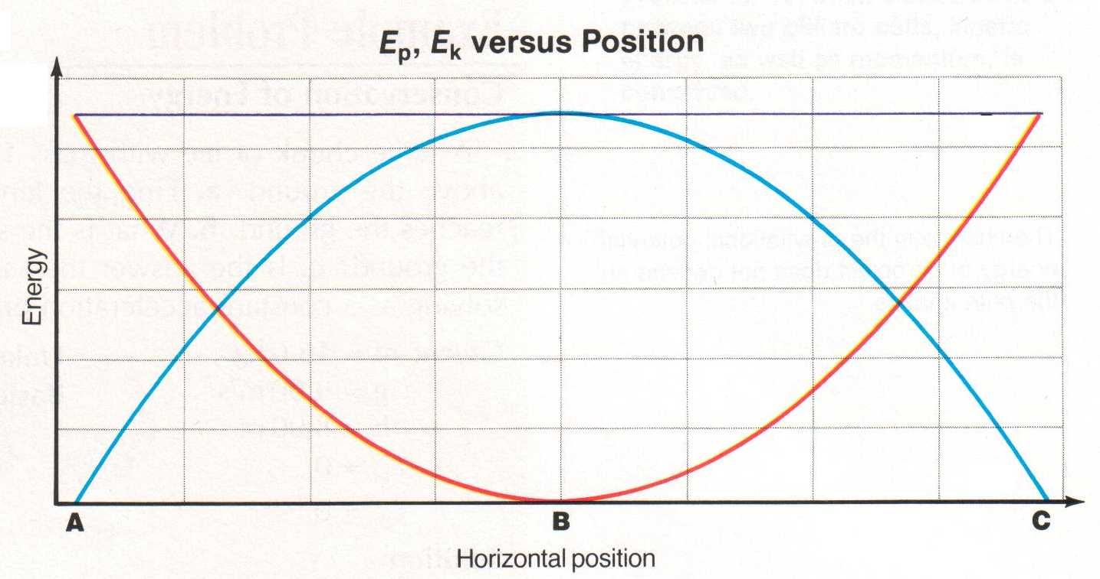
E_{k}
E_{p}

Throughout its motion a pendulum has a combination of kinetic and potential energies. Thus at any point the energy of the pendulum is equal to:
E_{total} = E_{p} + E_{k}

E_{total} = m g h + ½ m v²

At the top of the swing (h_{max}) the pendulum has no kinetic energy (E_{k} = 0). It has potential energy only. Thus
E_{total} = E_{p max} = m g h_{max}

At the bottom of a swing (v_{max}) the total energy is kinetic only. Thus

E_{total} = E_{k max} = ½ m v_{max} ²

A 2.0 kg mass on a string is pulled so that the mass is 1.274 m higher than at the equilibrium point. When it is released:
A. What is the maximum speed that the pendulum will have during its swing?

E_{total} = E_{k(Max)} = E_{p(Max)}

½ m v_{Max}² = m g h_{Max}

v_{Max}² = 2 g h = 2 (9.81m/s² )(1.274 m) = 25

v_{Max} = 5.0 m/s
B. What is the speed of the pendulum when it is half way down from its maximum height?
h_{1/2} = 1.274 m = 0.637 m E_{total} = E_{p(Max)} = E_{p} + E_{k}
2
m g h_{Max} =½ m v² + m g h_{1/2}

v² = 2 (g h_{Max} - g h_{1/2} )

v² = 2 [(9.81 m/s² )(1.274 m) - (9.81 m/s² )(0.637 m)]

v = 3.54 m/s

B. Horizontal Vibrating Springs

A vibrating horizontal mass on a spring is very similar to a pendulum. When the spring is at rest at its equilibrium position it will have no energy. However, displacing the mass from the equilibrium point gives the spring potential energy. When the mass is released, the spring potential is converted into kinetic energy. In turn the kinetic energy is converted into spring potential, which in turn is converted into kinetic energy and so on. Like a pendulum, a weighted vibrating spring has constant total energy. At any point the total energy is given by:
E_{total} = E_{p} + E_{k}

E_{total} = ½ k x² + ½ m v²

instantaneous speed
v

x
displacement from equilibrium

At the ends of its vibration the displacement is at a maximum (x_{max}) and the system is instantaneously at rest. Thus
E_{total} = E_{p max} = ½ k x_{max}²

At the equilibrium point (x = 0) the total energy is kinetic only (v_{max}). Thus

E_{total} = E_{k max} = ½ m v_{max}²

A 0.40 kg mass vibrates at the end of a horizontal spring along a frictionless surface. If the spring’s force constant is 55 N/m and the maximum displacement (amplitude) is 15 cm, what is the maximum speed of the mass as it passes through the equilibrium point?
E_{total} = E_{k(Max)} = E_{p(Max)}

½ m v_{Max}² = ½ k x_{Max}²

v_{Max}² = k x_{Max}² = 55 N/m (0.15 m)² = 3.094
m 0.40 kg
v_{Max} = 1.76 m/s

Momentum revisited
Many problems require a consideration of both the conservation of energy and the conservation of momentum. However, many physics students have difficulty deciding when to use momentum and/or energy to solve a problem. A general rule of thumb is that if the problem involves a collision or an explosion/recoil of some kind, then momentum must be used in the solution. Conversely, if no collisions are involved, the principle of the conservation of energy may be utilized in a solution. Perhaps the following example will illustrate the idea.

In the diagram below, ball A (mass = 5.0 kg) is traveling to the left at 12 m/s and collides with a stationary ball B (mass = 4.0 kg). After the collision ball A is moving at 1.40 m/s to the left. How high up the incline will ball B rise before coming to rest?

B
A
20º
d

The first part of the problem involves a collision between ball A and ball B. Thus we use the conservation of momentum to find the final speed of ball B. Once we know the speed of ball B, we can use the conservation of energy to determine how high it rises on the incline.

Part A – Find v_{B}’

Σp_{before} = Σp_{after}
m_{A}v_{a} = m_{a}v_{a}’ + m_{B}v_{B}’
v_{B}’ = 5.0 kg(12 m/s left) – 5.0 kg(1.40 m/s left) = 13.25 m/s left
4.0 kg
Part B – Find the height up the ramp
The kinetic energy of ball B after the collision is converted into potential energy (h).

E_{k} = E_{p}
½ m v² = m g h
h = ½ v²
g
h = ½ (13.25 m/s)² = 8.948 m
9.81 m/s²
d = h/sin 20º = 8.948 m/sin 20º
d = 26 m

Practice Problems
1. A 0.50 kg pendulum is pulled back and released. When the height is 0.60 m above its equilibrium position its speed is 1.9 m/s. What is the maximum height of the pendulum? (0.78 m)

2. A mass vibrates at the end of a horizontal spring (k = 125 N/m) along a frictionless surface reaching a maximum speed of 7.0 m/s. If the maximum displacement of the mass is 85.0 cm, what is the mass? (1.84 kg)

20 kg
5.0 kg

3. In the system shown to the right, the masses start from rest. Assuming a frictionless surface and pulley, what is the speed of each mass if the 5.0 kg mass is allowed to fall 1.2 m? (2.2 m/s)

Hand-in Assignment
1. Furniture movers wish to load a truck using a ramp from the ground to the rear of the truck. One of the movers claims that less work would be required if the ramp's length were increased, reducing its angle with the horizontal. Is this claim valid? Explain.

2. The drivers of two identical cars heading toward each other apply the brakes at the same instant. The skid marks of one of the cars are twice as long as the skid marks of the other vehicle. Assuming that the tires of both cars apply the same force, what conclusions can you draw about the motion of the cars?

3. Each of the following objects possesses energy. Which forms of energy are mechanical and which are non-mechanical?
a. glowing embers in a campfire
b. a strong wind
c. a swinging pendulum
d. a person sitting on a mattress
e. a rocket being launched into space

4. Advertisements for a toy ball once stated that it would rebound to a height greater than the height from which it was dropped. Is this possible?

5. What is the kinetic energy of an automobile with a mass of 1250 kg traveling with a speed of 11 m/s? What speed would a fly with a mass of 0.55 g need in order to have the same kinetic energy as the automobile? (7.6 x 10⁴ J, 1.7 x 10⁴ m/s)

6. Tarzan swings on a 30.0 m long vine initially inclined at an angle of 37.0° with the vertical. What is his speed at the bottom of the swing if he does the following:
a. starts from rest? (10.9 m/s)
b. pushes off with a speed of 4.00 m/s? (11.6 m/s)

7. A 5.00 g bullet moving at 600.0 m/s penetrate tree trunk to a depth of 4.00 cm.
a. Use work and energy considerations to find the average frictional force that stops the bullet. (2.25 x 10⁴ N)
b. Assuming that the frictional force is constant determine how much time elapses between the moment the bullet enters the tree and the moment the bullet stops moving. (1.33 x 10⁻⁴ s)

8. A 0.250 kg block on a vertical spring with a spring constant of 5.00 x 10³ N/m is pushed downward, compressing the spring 0.100 m. When released, the block leaves the spring and travels upward vertically. How high does it rise above the point of release? (10.2 m)

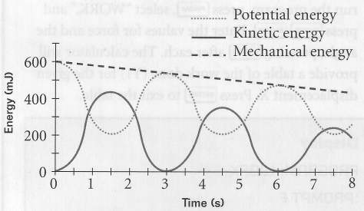
9. To the right is a graph of the gravitational potential energy and kinetic energy of a 75 g yo-yo as it moves up and down on its string. Use the graph to answer the following questions:
a. By what amount does the mechanical energy of the yo-yo decrease after 6.0 s? (~120 mJ)
b. What is the speed of the yo-yo after 4.5 s? (~3.3 m/s)
c. What is the maximum height of the yo-yo? (82 cm)

10. A 4.0 kg mass vibrates at the end of a horizontal spring along a frictionless surface reaching a maximum speed of 5.0 m/s. If the maximum displacement of the mass is 11.0 cm, what is the spring constant? (8.3 x 10³ N/m)

11. An object vibrates at the end of a horizontal spring, spring constant = 18 N/m, along a frictionless horizontal surface. If the maximum speed of the object is 0.35 m/s and its maximum displacement is 0.29 m, what is the speed of the object when the displacement is 0.20 m? (0.25 m/s)

12. A 0.750 kg object vibrates at the end of a horizontal spring (k = 955 N/m) along a frictionless surface. The speed of the object is 0.250 m/s when its displacement is 0.145 m. What is the maximum displacement and speed of the object? (0.145 m,
5.17 m/s)

13. A 1.35 kg pendulum bob is hung from a 3.20 m string. When the pendulum is in motion, its speed is 2.40 m/s when its height is 85.0 cm above the equilibrium point. What is the maximum speed of the pendulum? What is the period of vibration for the pendulum? (4.74 m/s, 3.59 s)

14. A 0.25 kg pine cone falls from a branch 20 m above the ground. (a) With what speed would it hit the ground if air resistance could be ignored? (b) If it actually hits the ground with a speed of 9.0 m/s, what was the average force of air resistance exerted on it? (20 m/s, 1.9 N)

15. A ballistic pendulum is a laboratory device which might be used to calculate the velocity of a bullet. A 5.0 g bullet is caught by a 500 g suspended mass. After impact, the two masses move together until they stop at a point 65 mm above the point of impact. What was the velocity of the bullet prior to impact?
65 mm
V = ?
(114 m/s)

16. For the pulley system illustrated to the right, when the masses are released, what is the final speed of the 12 kg mass just before it hits the floor? (7.0 m/s)
4.0 kg
12 kg

5.0 m

Physics 30 Hot Wheels Activity

Problem:

What is the relationship between the potential energy of a car at the top of a hill and its kinetic energy at the bottom of a hill? How much heat was lost due to friction? What is the average frictional force of the track on the car? (Hint: You cannot use conservation of energy to calculate the speed at the bottom of the ramp.)
ramp
h (measure)
Δd_{x} (measure)
Δd_{y} (measure)

foamy on floor
E_{p} = m g h
E_{k} = ½ m v²
table top

